**Lab 39**

**Self-Practice Solution: Creating Linux VM on Azure**

**Task: Linux VM**

**Creating Your First Linux VM in Azure cloud**

Azure virtual machines (VMs) can be created through the Azure portal. The Azure portal is a browser-based user interface to create Azure resources. This quick start shows you how to use the Azure portal to deploy a Linux virtual machine (VM) running Ubuntu 18.04 LTS. To see your VM in action, you also SSH to the VM and install the NGINX web server.

***Sign in to Azure***

Sign in to the Azure Portal if you haven't already.

***Create virtual machine***

1. Type **virtual machines** in the search.
2. Under **Services**, select **Virtual machines**.
3. In the **Virtual machines** page, select **Add**. The **Create a virtual machine** page opens.
4. In the **Basics** tab, under **Project details**, make sure the correct subscription is selected and then choose to **Create new** resource group. Type *myResourceGroup* for the name.*.

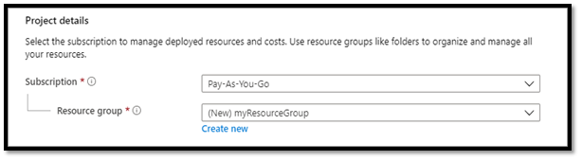

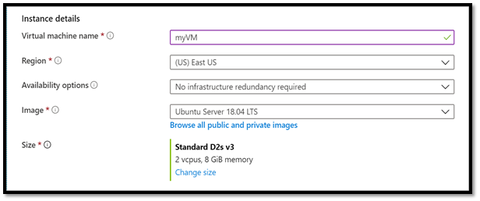

1. Under **Instance details**, type *myVM* for the **Virtual machine name**, choose *East US* for your **Region**, and choose *Ubuntu 18.04 LTS* for your **Image**. Leave the other defaults.
2. Under **Administrator account**, select **SSH public key**.
3. In **Username** type *azureuser*.
4. For **SSH public key source**, leave the default of **Generate new key pair**, and then type *myKey* for the **Key pair name**.

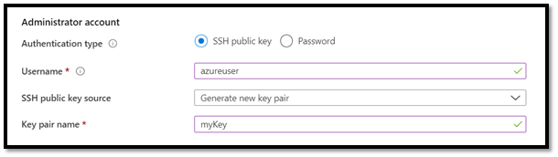

1. Under **Inbound port rules** > **Public inbound ports**, choose **Allow selected ports** and then select **SSH (22)** and **HTTP (80)** from the drop-down.

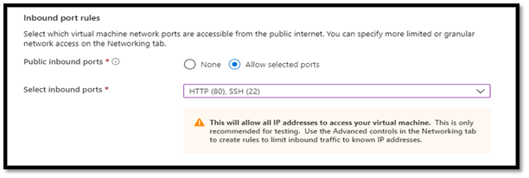

1. Leave the remaining defaults and then select the **Review + create** button at the bottom of the page.
2. On the **Create a virtual machine** page, you can see the details about the VM you are about to create. When you are ready, select **Create**.
3. When the **Generate new key pair** window opens, select **Download private key and create resource**. Your key file will be download as **myKey.pem**. Make sure you know where the .pem file was downloaded, you will need the path to it in the next step.
4. When the deployment is finished, select **Go to resource**.
5. On the page for your new VM, select the public IP address and copy it to your clipboard.

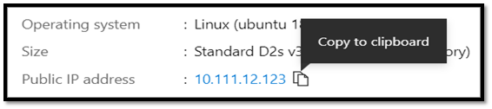

**Connect to Virtual Machine**

***Create an SSH connection with the VM.***

1. If you are on a Mac or Linux machine, open a Bash prompt. If you are on a Windows machine, open a PowerShell prompt.
2. At your prompt, open an SSH connection to your virtual machine. Replace the IP address with the one from your VM, and replace the path to the .pem with the path to where the key file was downloaded.

***Console***

ssh -i .\Downloads\myKey1.pem azureuser@10.111.12.123

***Tip***

The SSH key you created can be used the next time you create a VM in Azure. Just select the **Use a key stored in Azure** for **SSH public key source** the next time you create a VM. You already have the private key on your computer, so you won't need to download anything.

***Install web server***

Bash

sudo apt-get -y update

sudo apt-get -y install nginx

When done, type exit to leave the SSH session.

**Clean up resources**

When no longer needed, you can delete the resource group, virtual machine, and all related resources. To do so, select the resource group for the virtual machine, select **Delete**, then confirm the name of the resource group to delete.